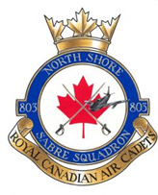
803 North Shore Sabre Squadron

Lesson Plan

EO: |  |  | Instructor:
Title:
Location of Lesson:
Time of Lesson:

Introduction | Time | Comments
Material Taught (WHAT)

Goal (WHY)

Application (WHEN)

Teaching Point 1 | Time | Comments
Confirmation of TP1
Teaching Point 2 | Time | Comments
Confirmation of TP2
Teaching Point 3 | Time | Comments
Confirmation of TP3
Overall Performance Check | Time | Comments
Conclusion | Time | Comments
Summary (Main Teaching Points)

Repeat of WHY & WHEN (from introduction)

